Final Project: Design Decisions
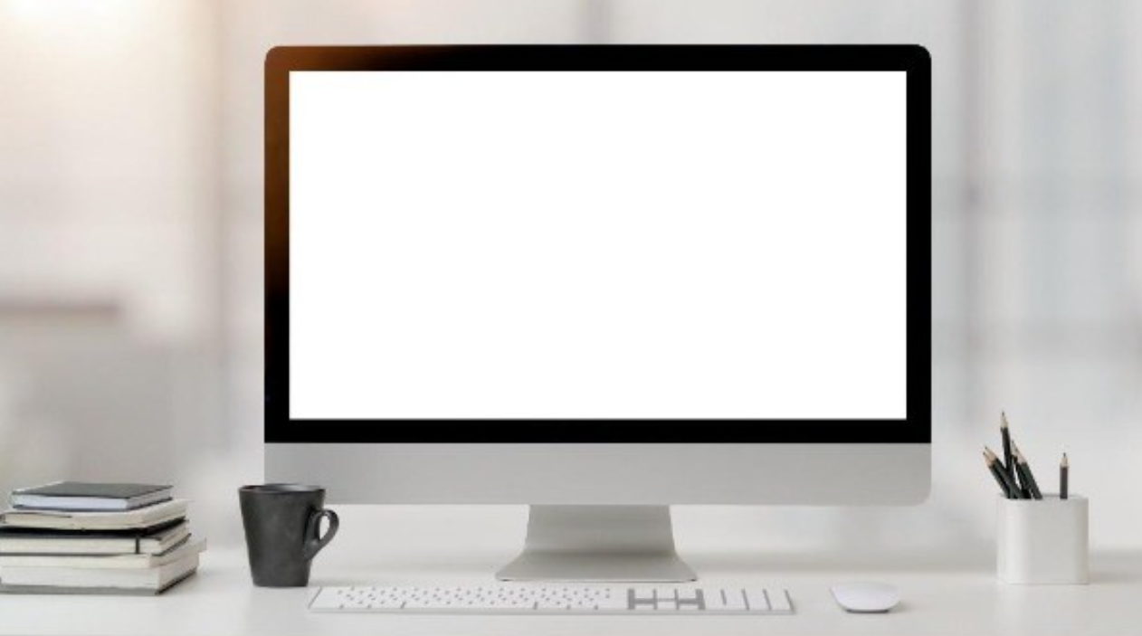
For my final project, I recreated a modern computer workstation shown in the selected 2D reference image. The main goal was to match the overall layout of the original image while using low-polygon OpenGL shapes. The scene includes a desk, monitor, keyboard, mouse, stack of books, coffee mug, pencil cup and pencils. I selected these objects because they've recognizable shapes and could be built from provided primitive meshes without making the scene overly complex.
The desk is the base of the scene and was created with a large flattened box for the tabletop and 4 smaller boxes for the legs. I used a marble texture on the tabletop and repeated texture coordinates so that the texture wouldn't appear stretched. The monitor is the main object in the center of the scene. It's made from flattened box for the black frame, another thin box for the white screen, a tapered cylinder for the vertical support and a flattened box for the base. This helped the monitor resemble the reference image while keeping the design simple.
The books on the left are represented with 3 flattened boxes. I rotated the books slightly so they don't look perfectly identical or stacked in an unnatural way. Thin torus shapes were added to represent the spiral binding on the top notebook. Black coffee mug is made from multiple primitives. The body uses a hollow tapered cylinder, the handle uses a half-torus and a flattened torus is used for rim. This was an important object because it demonstrates how multiple primitive shapes can be combined into 1 more complex object.
The pencil cup on the right is made from 5 thin boxes: 4 sides and 1 bottom. The pencils use thin cylinders for their bodies and cones for their sharpened tips. The keyboard is a flattened box with small boxes added as keys. The mouse uses a flattened cylinder for the lower section and a half-sphere for the curved top. These choices kept the scene below required polygon limit while still making the objects easy to recognise.
Lighting was added to make the scene more polished. I used 2 point lights. First is warm light placed above and to the left of the desk. The second is a cool blue fill light placed on the opposite side. The lights use ambient, diffuse and specular components from the Phong lighting model. This makes the objects visible from different camera positions and prevents the darker objects, such as the mug, from becoming completely black.
The user can navigate the scene using several input devices. The W and S keys move the camera forward and backward. The A and D keys move the camera left and right. The Q and E keys move the camera up and down. Mouse movement changes the camera pitch and yaw so the user can look around scene. The mouse scroll wheel adjusts movement speed. The P key changes the display to perspective projection, while the O key changes it to orthographic projection. These controls allow the user to inspect the scene from different positions and angles.
I used several custom functions to keep the program organised. PrepareScene() loads the meshes, textures, materials and lighting needed before rendering. LoadSceneTextures() loads the image files into OpenGL texture memory. DefineObjectMaterials( creates material values such as diffuse color, specular color and shininess. SetupSceneLights() configures the 2 point lights. SetTransformations() applies scaling, rotation and translation to each object before it's drawn. RenderScene() contains the drawing commands for the desk and all workstation objects. Organising the code this way made it easier to update individual objects and reuse the same meshes multiple times

